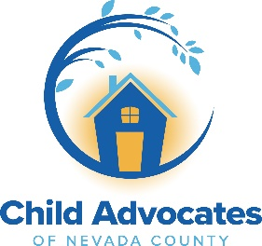

**Do You Like Working with Families and Babies?**

**Pay**

$23.00/Hr.

FULL TIME- 32-40 Hours per week

**Home Visitor – Western Nevada County**

Child Advocates of Nevada County is a family provider in the community. If you love working with families and babies, this is the job for you!

Healthy Babies seeks a full-time Home Visitor for the Healthy Babies (HB) Home Visiting Program in the Nevada City and Grass Valley areas. Home Visitors receive extensive training to offer assessments to parents for bonding with their baby, pre/post-natal depression, growth development, parenting curriculum, resources, and support to families.

**Apply through our website at** [**https://caofnc.org/healthy-babies/**](https://caofnc.org/healthy-babies/)

**Duties**: Under the direction of the Supervisor, the Home Visitor conducts outreach and home visits with assigned families in the Western Nevada County community. The Home Visitor will help families identify strengths, develop a strong parent/child bond, connect with resources, and set and meet goals. This position will also provide initial assessments to interested families.

**$1,000 Bonus** for bilingual in Spanish after completion of probation. Bilingual **PREFERRED**

**Minimum Requirements:**

Minimum of a high school diploma or equivalent • experience in working with or providing

services to children and families • an ability to establish trusting relationships • acceptance of

individual differences • experience and humility to work with culturally diverse families •

knowledge of infant and child development • willing to engage in building reflective capacity

(e.g., capacity for introspection, communicating awareness of self in relation to others,

recognizing the value of supervision, etc.) • infant mental health endorsement preferred (if

available in the state; if unsure, you can find out on the IMH website)

Familiarity with Microsoft Suite software.

**HOW TO APPLY: Apply online through our website at**

**to view the full job description. Applications must be made on our website. Please also upload a cover letter and your current resume at:** [**https://caofnc.org/healthy-babies/**](https://caofnc.org/healthy-babies/)

Partial Hybrid work environment-Minimum 50% in office.

Child Advocates of Nevada County is an equal opportunity employer.